Vehicle Pattern Recognition using Machine & Deep Learning to Predict Car Model

In this project we are using know inference features and pattern features to predict car model using various machine learning algorithms such as SVM, KNN, CNN and Linear Regression. To implement this project we have used Stanford car dataset and below screen shots showing some images from dataset

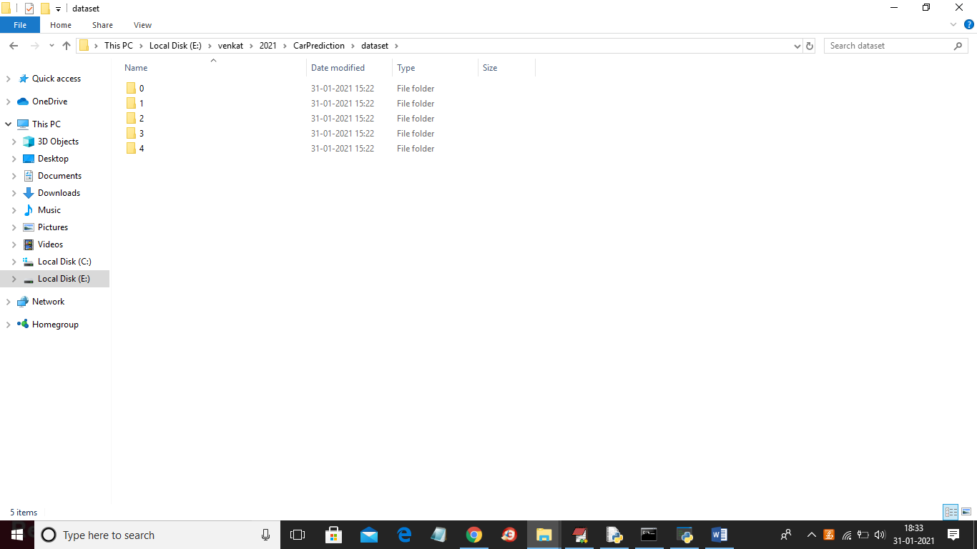

In above screen we are using images from five different car model and each folder contains different images and below is the images from 0 folder

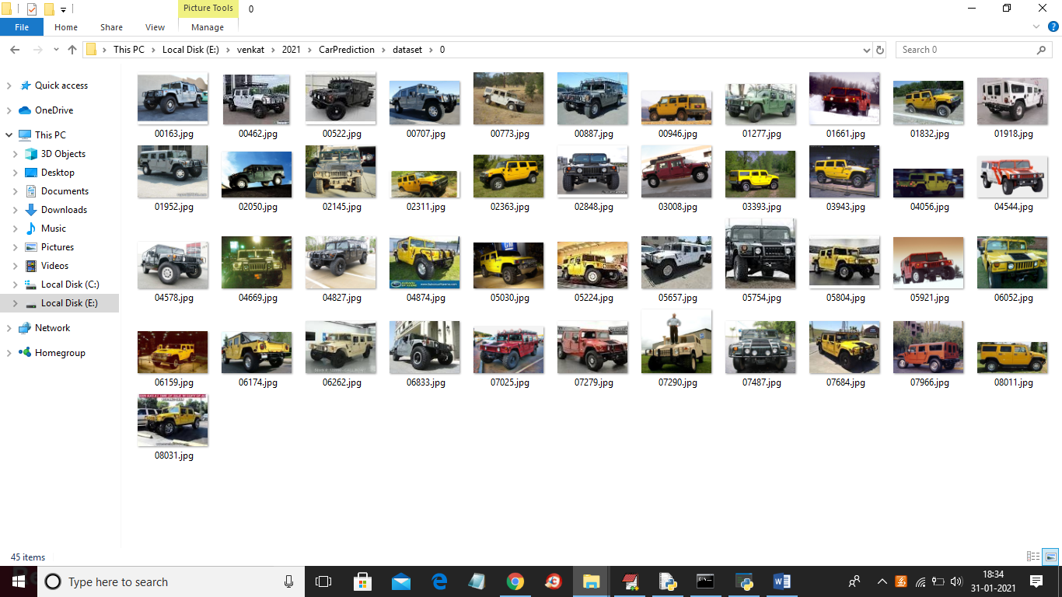

To run project double click on ‘run.bat’ file to get below screen

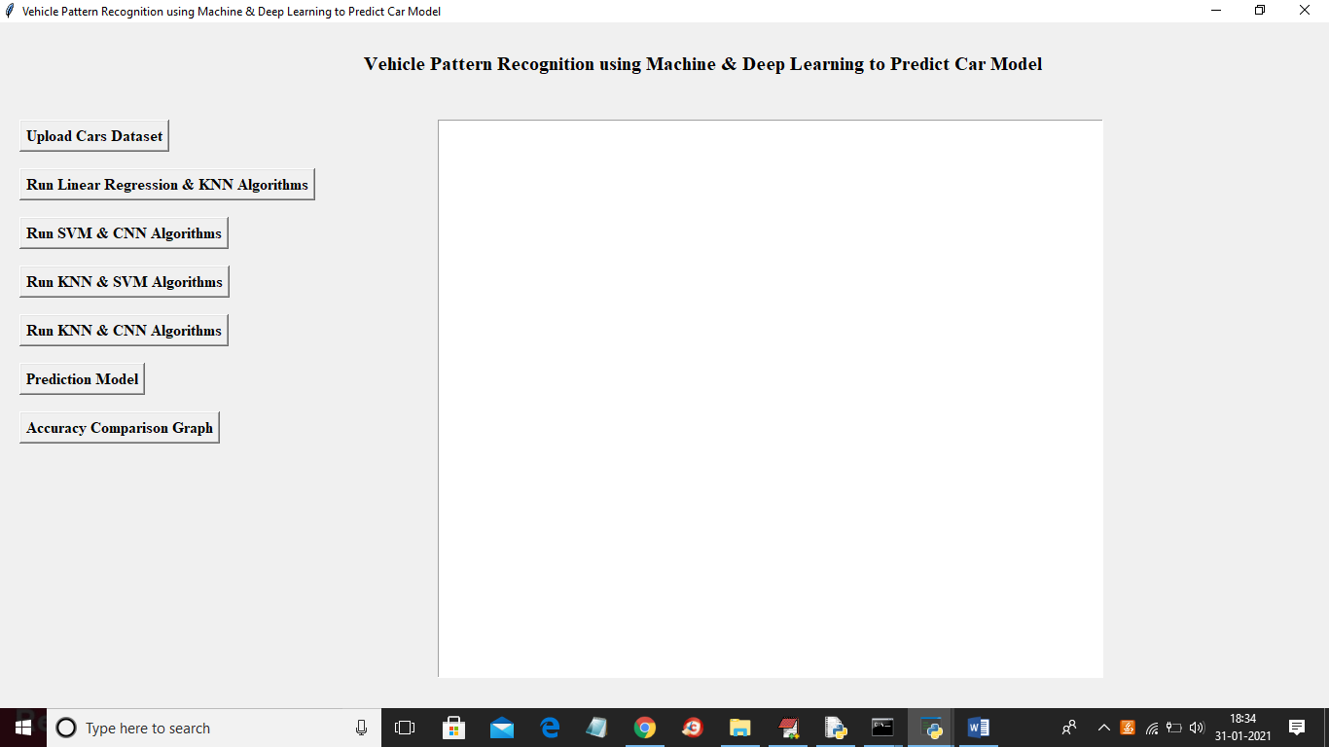

In above screen click on ‘Upload Cars Dataset’ button to load dataset

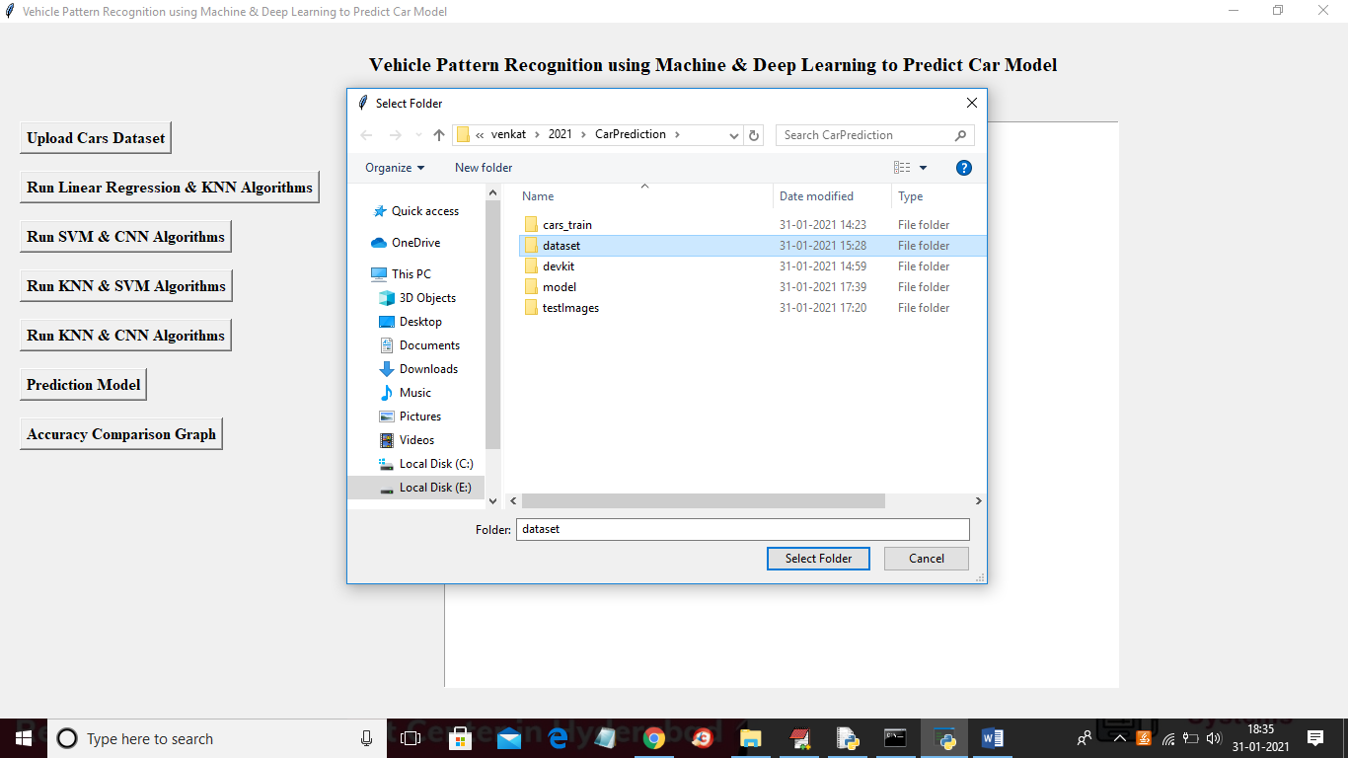

In above screen selecting and uploading ‘dataset’ folder and then click on ‘Select Folder’ button to load dataset and to get below screen

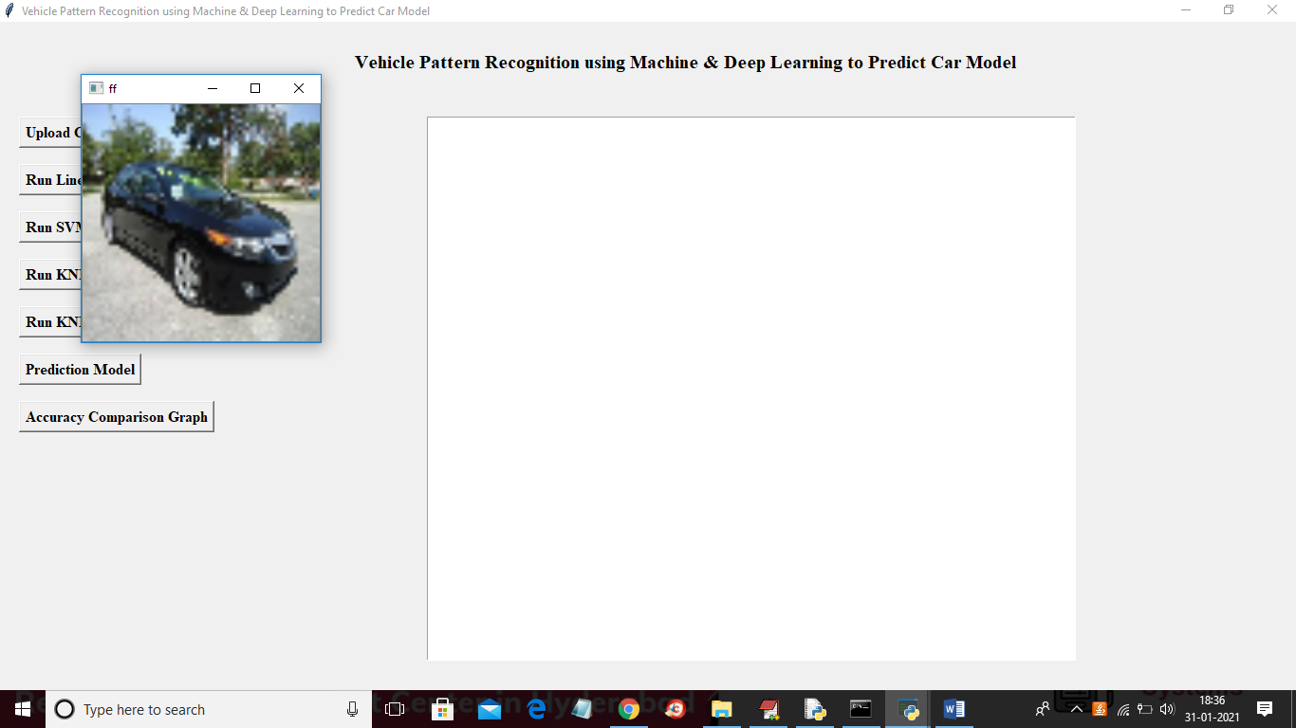

In above screen showing one sample image to see dataset loaded correctly and now close above image to get below screen

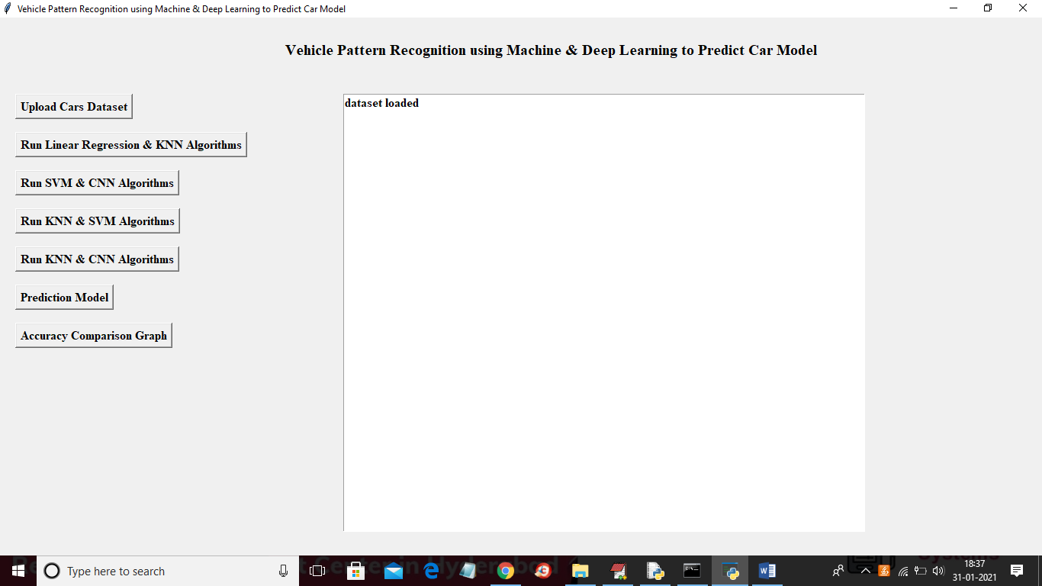

In above screen dataset loaded and now click on ‘Run Linear Regression & KNN Algorithm’ button to apply dataset on both algorithms and to calculate prediction accuracy

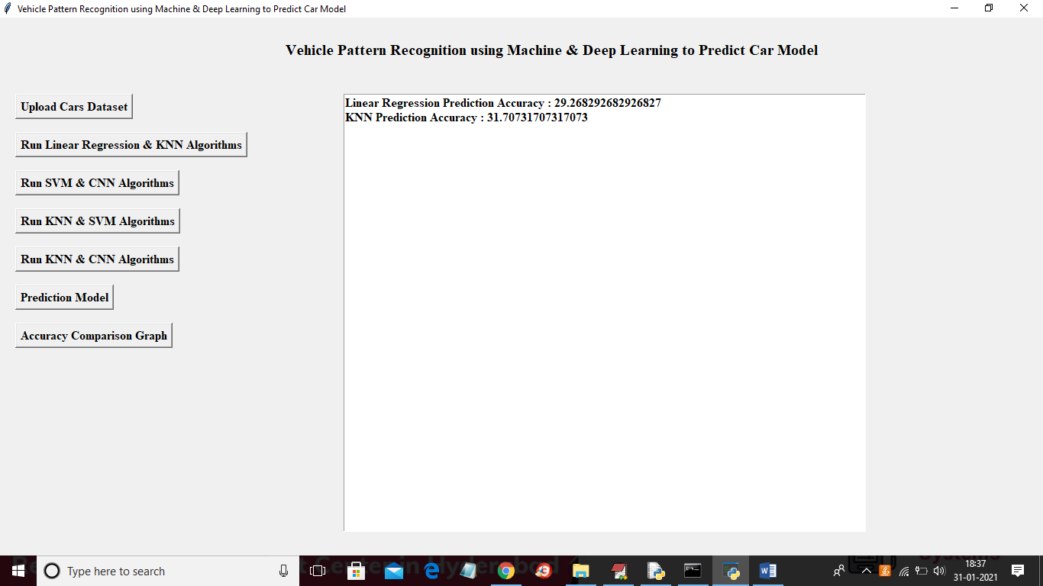

In above screen Linear regression accuracy is 29% and KNN accuracy is 31% and now click on ‘Run SVM & CNN Algorithm’ button to get pattern accuracy

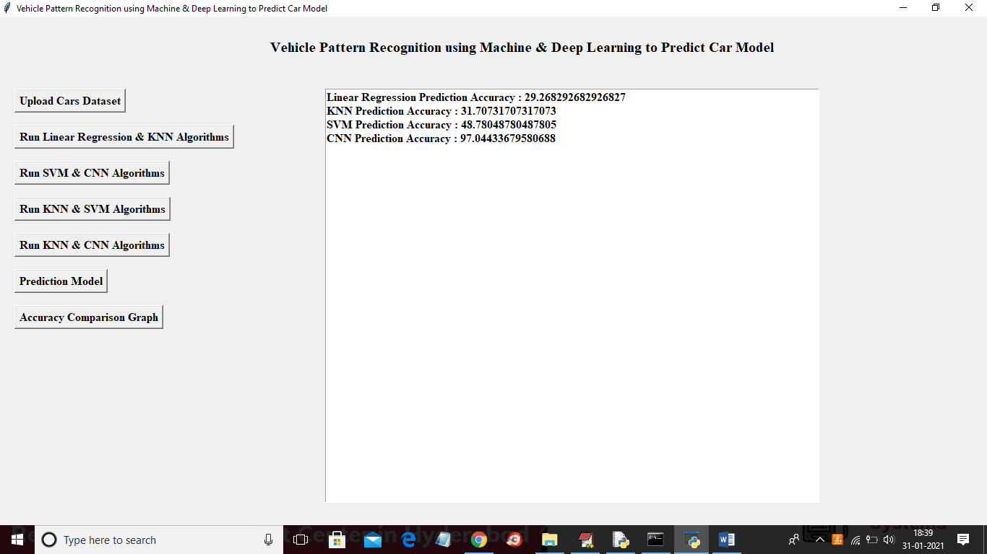

In above screen SVM accuracy is 48% and CNN is 97% for pattern features and now click on ‘Run KNN & SVM Algorithm’ button to run inference features from dataset

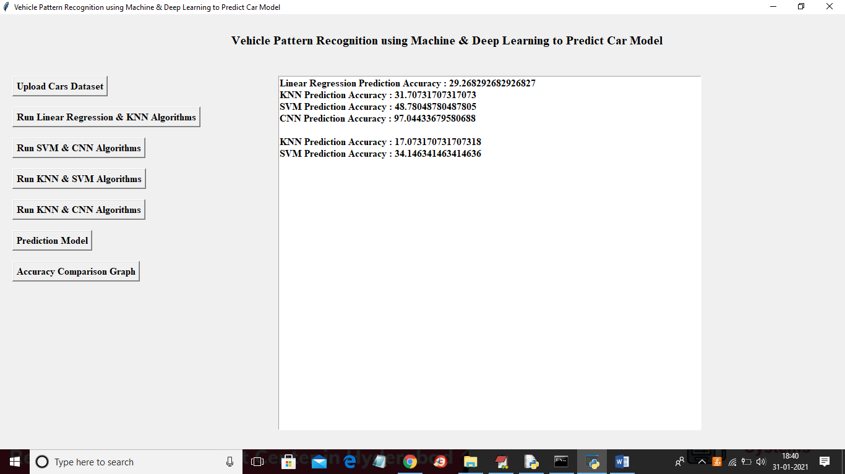

In above screen KNN accuracy is 17% and SVM accuracy is 34% and now click on ‘Run KNN & CNN Algorithms’ button to calculate its accuracy on inference features

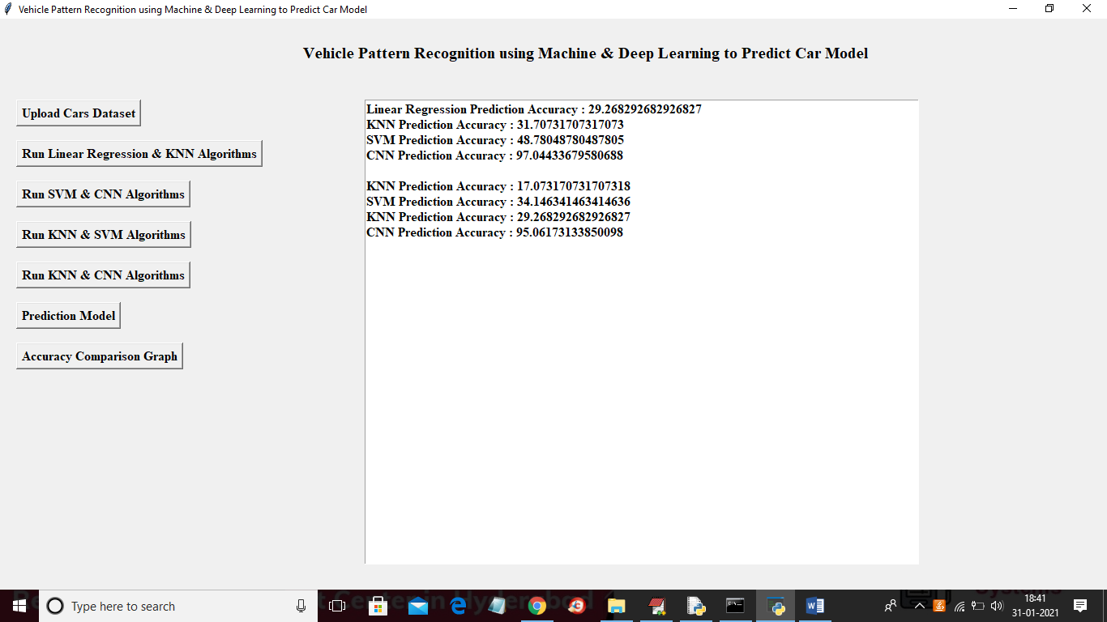

In above screen KNN inference accuracy is 29% and CNN accuracy is 95% and now click on ‘Prediction Model’ button to upload test image and get it predicted model

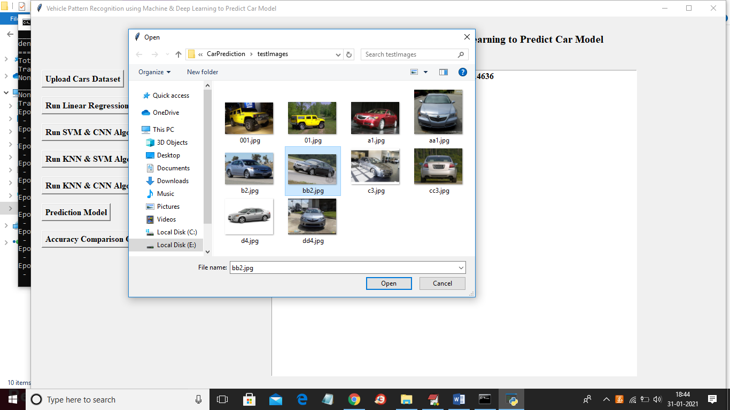

In above screen selecting and uploading ‘bb2.jpg’ and then click on ‘Open’ button to get below prediction result

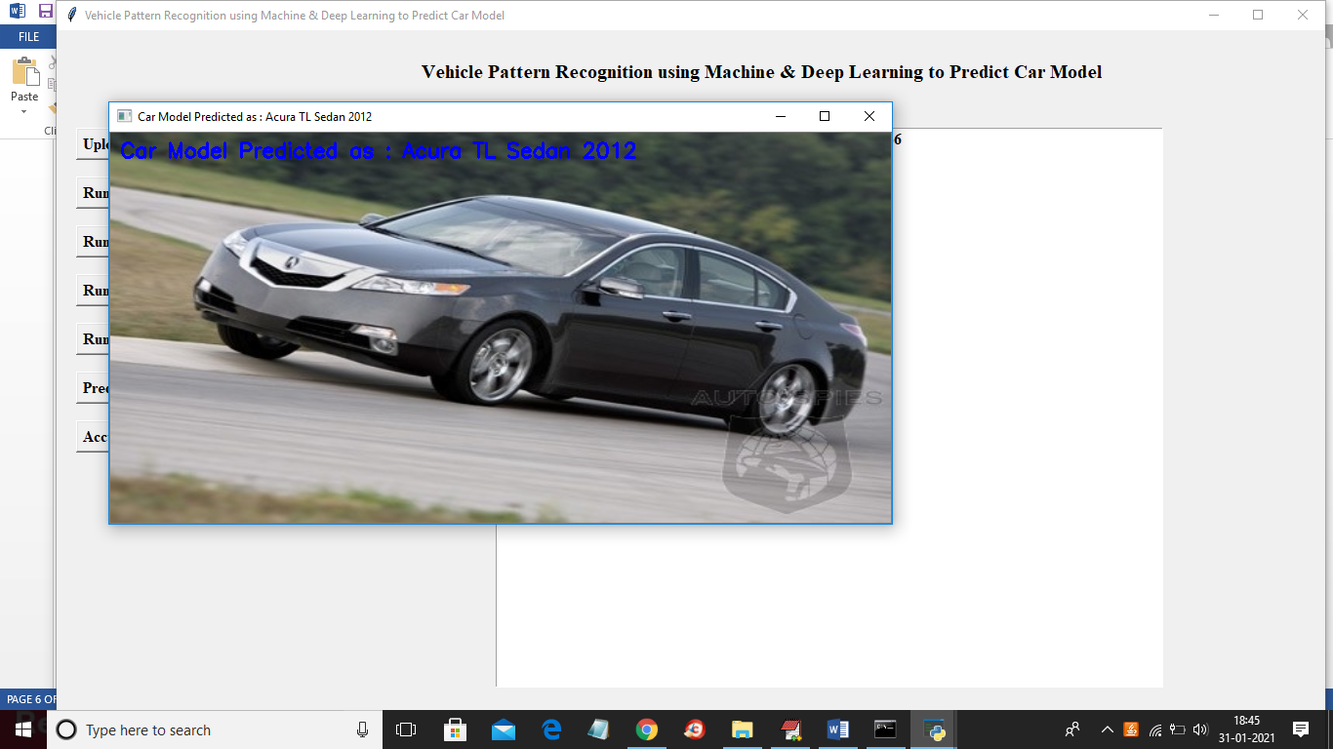

Similarly you can upload any image and get it model predicted. Now click on ‘Accuracy Comparison Graph’ button to get below screen

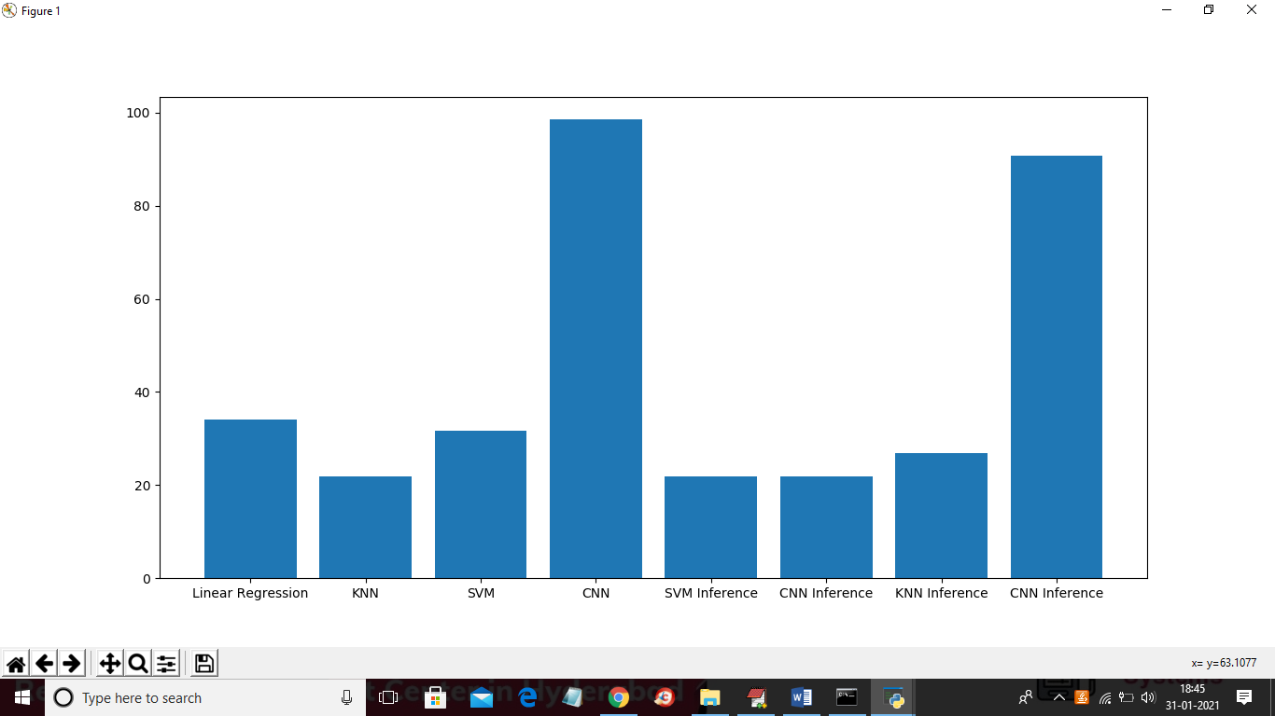

In above screen x-axis represents algorithm name and y-axis represents accuracy of that algorithm